Herein, find a brief review of the presence of Avian piscivorous predators and efficacy of their dissuasion at Ringold Springs on 14 June, 2002. The purpose of the dissuasion was to provide protection to the roughly 4.5 million subyearling upriver bright (URB) Fall Chinook salmon released from the Ringold Springs Hatchery 9 acre pond, and through its outflow channel to the Columbia River.

The intent of this brief is to review conditions and actions as part of a broader effort to inform the Region of release conditions and dissuasion efficacy. This review is provided to support future planning efforts to better safeguard hatchery fish and bolster return rates from these and other hatchery releases.

**Avian Presence:**

White Pelicans, Gulls, Caspian Terns (CATE), and Egrets were the primary avian piscivorous species observed in and around the 9 Acres URB rearing pond, outflow channel, and at the confluence of the outflow channel and the Columbia River.

The number of White Pelican observed working downstream of the outfall channel in the Columbia River *(ca*. 15-20) were greatly reduced relative to those observed in 2021 (Figure 2). The number of CATE and Egrets present and the confluence with the Columbia River was difficult to estimate from the shoreline, buy were likely less than 50 CATE, and less than 10 Egrets. Some birds were observed sitting on and near debris that stacked up on the no fishing sign near the outfall (Figure 3). In addition to those seen near the outfall and no fishing sign, an unknown number of White Pelicans were observed loafing on an Island located downstream of the outfall.

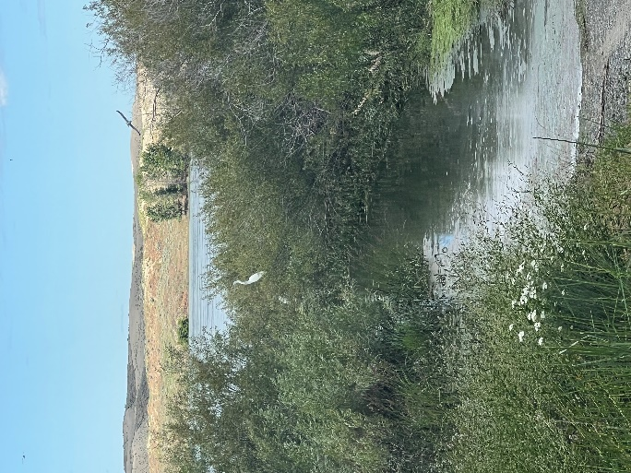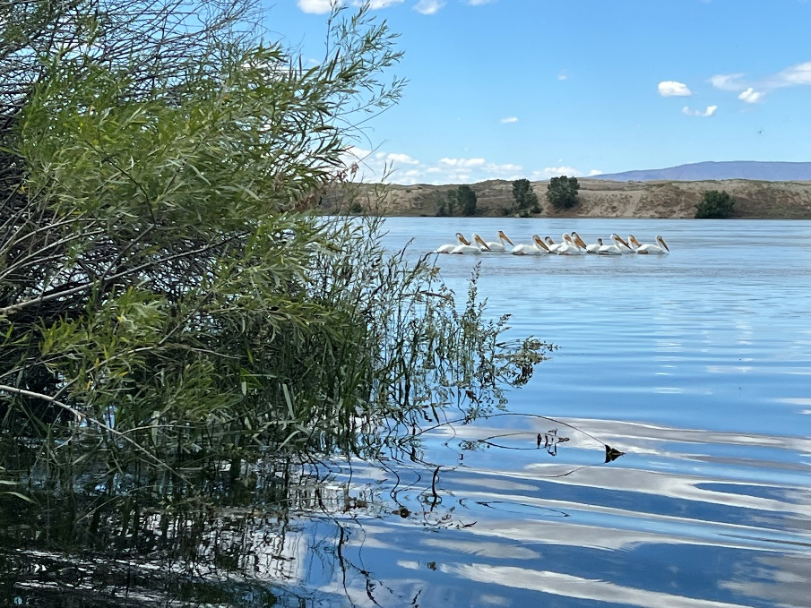

Figure 2. Egret (left) and Pelicans (right) observed near the outfall at Ringold Springs Hatchery.

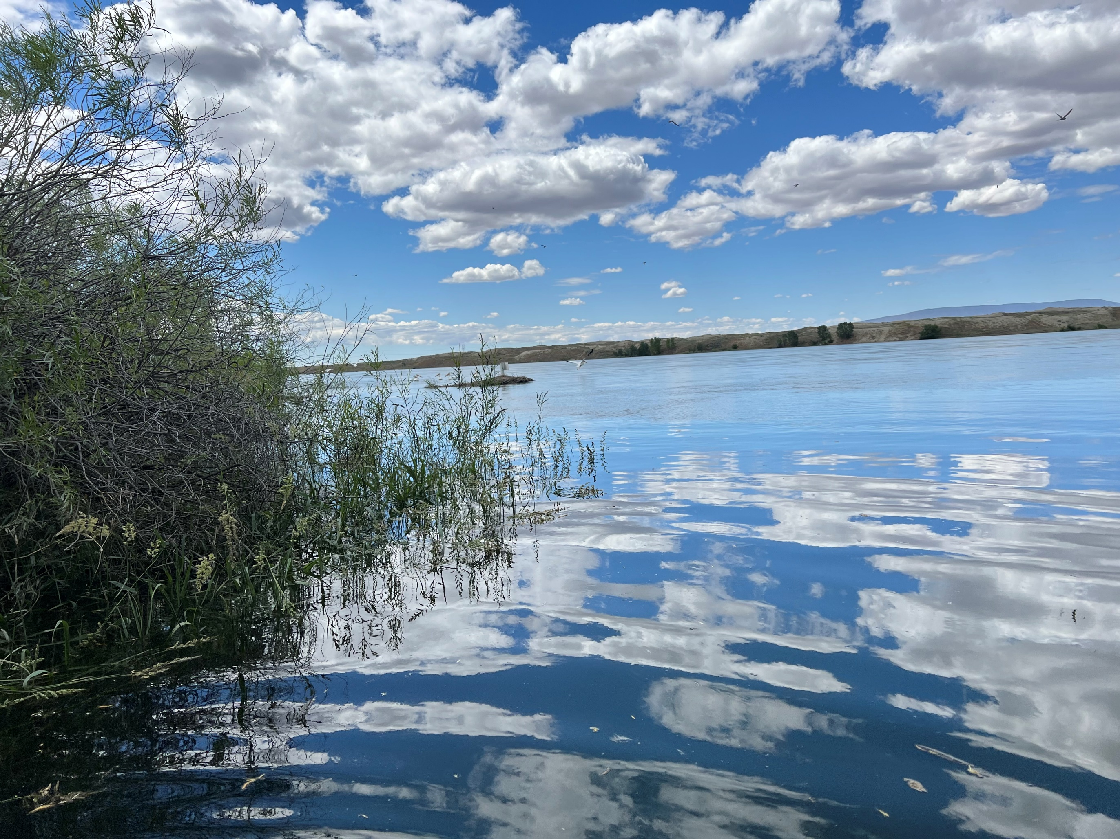

Figure 3. Debris on “no fishing sign” that birds were resting on and may have been used either as a current break or feeding area near the outfall at Ringold Springs Hatchery.

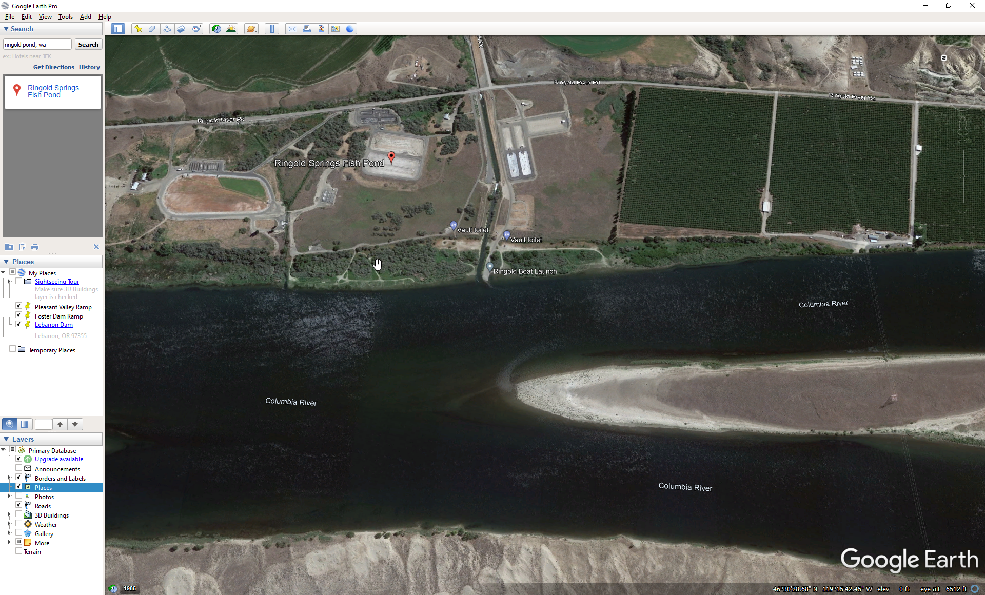

Figure 4. Pelicans were observed loafing on the upstream end of the island located downstream of Ringold Springs Hatchery outfall.

**Avian Dissuasion:**

A WDFW wildlife conflict biologist conducted some dissuasion from the shoreline with cracker shells and screamers. The hazer was unable to get close to the birds due to high water which somewhat limited the dissuasion effectiveness after multiple volleys (e.g., habituation to hazing).

The WDFW is replicating last year’s PIT releases at the Boat launch in addition to fish exiting the outfall, so we will be able to compare survival from the outfall channel like we did last year. The PIT recoveries from 2021 suggested birds feeding near the outfall may have consumed up to 4% of the release in comparison to 1% of those released at the boat launch.

**Action Items:**

Update Region on Pelican presence on the island downstream of the Ringold outfall for potential PIT Recovery efforts to better estimate White Pelican Impacts.

Evaluate WDWF release survival estimates once provided and develop recommendations to better dissuade Avian predation in the future.

Review acceptable hazing methodologies and brainstorm means to enhance the protection afforded to hatchery releases. For instance, If the Columbia River water level is high at Ringold, boat hazing will likely be more effective, than from shore. It may be plausible that Norther Pikeminnow anglers who have reported good success near the release site, may voluntarily fish during release periods. If anglers are actively fishing during releases; focusing, pike minnow removal in and around the outfall may be advantageous.